HYBRID APPLICATION DEVELOPMENT LAB

Chandini T R

1NT20IS403

# **Alertdialog, Imageview and Listview Demo**

**Alert dialogue**

*<?*xml version="1.0" encoding="utf-8"*?>*  
<LinearLayout xmlns:android="http://schemas.android.com/apk/res/android"  
 xmlns:app="http://schemas.android.com/apk/res-auto"  
 xmlns:tools="http://schemas.android.com/tools"  
 android:layout_width="match_parent"  
 android:layout_height="match_parent"  
 tools:context=".MainActivity"  
 android:orientation="vertical">  
  
  
 <TextView  
 android:id="@+id/textView"  
 android:layout_width="290dp"  
 android:layout_height="wrap_content"  
 android:text="ALERT MESSAGE"  
 app:layout_constraintBottom_toBottomOf="parent"  
 app:layout_constraintEnd_toEndOf="parent"  
 app:layout_constraintHorizontal_bias="0.498"  
 app:layout_constraintStart_toStartOf="parent"  
 app:layout_constraintTop_toTopOf="parent"  
 android:textSize="20dp"  
 app:layout_constraintVertical_bias="0.179" />  
 <Button  
 android:layout_width="match_parent"  
 android:layout_height="wrap_content"  
 android:id="@+id/alert"  
 android:layout_marginRight="30dp"  
 android:layout_marginLeft="30dp"  
 android:text="CLICK HERE TO ALERT"  
 />  
  
</LinearLayout>

**Mainactivity.java**

package com.example.alert;  
  
import androidx.appcompat.app.AlertDialog;  
import androidx.appcompat.app.AppCompatActivity;  
  
import android.content.DialogInterface;  
import android.os.Bundle;  
import android.view.View;  
import android.widget.Button;  
import android.widget.Toast;  
  
public class MainActivity extends AppCompatActivity {  
 Button alertButton;  
  
 @Override  
 protected void onCreate(Bundle savedInstanceState) {  
 super.onCreate(savedInstanceState);  
 setContentView(R.layout.*activity_main*);  
 alertButton = findViewById(R.id.*alert*) ;  
 alertButton.setOnClickListener(new View.OnClickListener() {  
 @Override  
 public void onClick(View view) {  
 alertButton = findViewById(R.id.*alert*) ;  
 alertButton.setOnClickListener(new View.OnClickListener() {  
 @Override  
 public void onClick(View view) {  
 AlertDialog.Builder builder = new AlertDialog.Builder(MainActivity.this) ;  
 builder.setIcon(R.drawable.*ic_launcher_background*) ;  
 builder.setTitle("Alert Title") ;  
 builder.setMessage("Shall I Close this window, Y/N?") ;  
 builder.setPositiveButton("Yes", new DialogInterface.OnClickListener() {  
 @Override  
 public void onClick(DialogInterface dialogInterface, int which) {  
 Toast.*makeText*(MainActivity.this, "you have pressed yes", Toast.*LENGTH_SHORT*).show();  
 }  
 });  
 builder.setNegativeButton("No", new DialogInterface.OnClickListener() {  
 @Override  
 public void onClick(DialogInterface dialogInterface, int which) {finish();}} );  
 AlertDialog alertDialog =builder.create();alertDialog.show(); }  
 }  
 ); }  
 }  
 ); }  
}

**OUTPUT:**

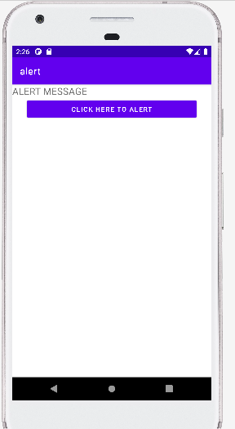

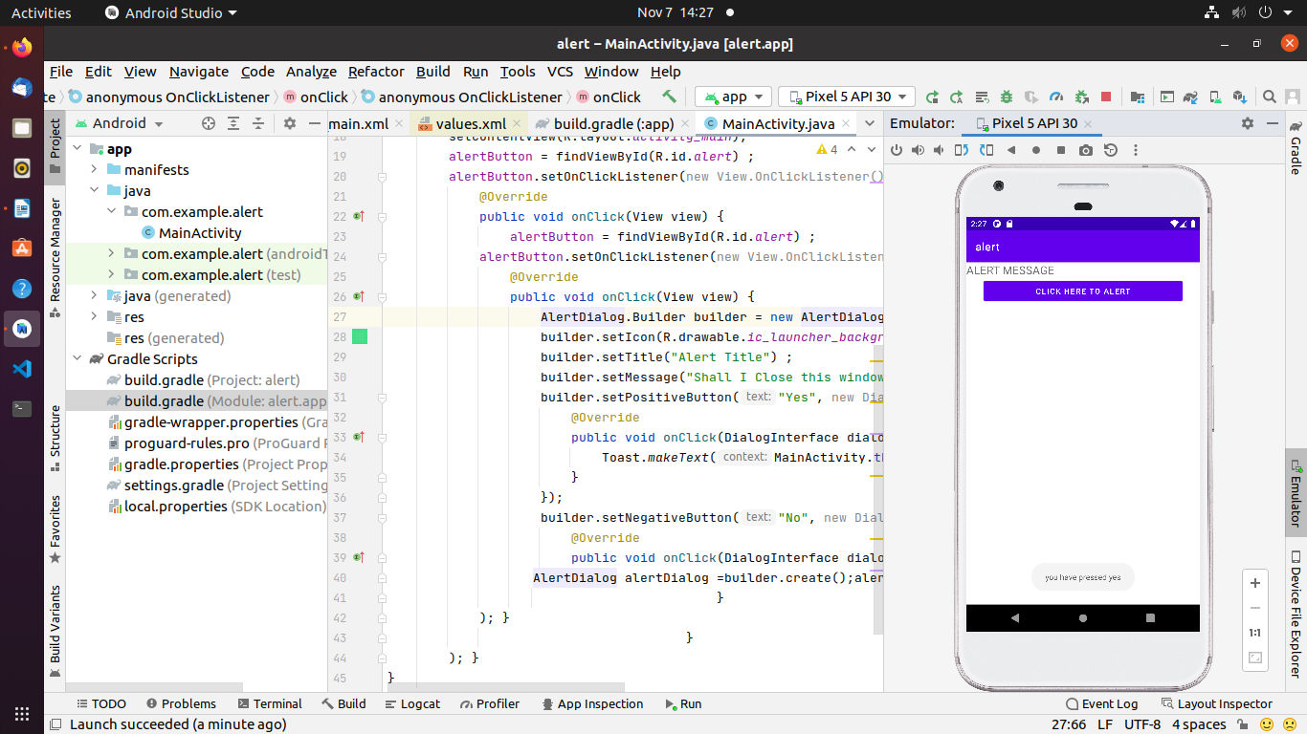

**Image View**

Activity_main.xml

*<?*xml version="1.0" encoding="utf-8"*?>*  
<LinearLayout xmlns:android="http://schemas.android.com/apk/res/android"  
 xmlns:app="http://schemas.android.com/apk/res-auto"  
 xmlns:tools="http://schemas.android.com/tools"  
 android:layout_width="match_parent"  
 android:layout_height="match_parent"  
 android:orientation="vertical"  
 tools:context=".MainActivity">  
 <ImageView  
 android:id="@+id/myImg"  
 android:layout_width="match_parent"  
 android:layout_height="400dp"  
 android:layout_margin="20dp"  
 android:src="@drawable/ch1"  
 app:layout_constraintBottom_toBottomOf="parent"  
 app:layout_constraintEnd_toEndOf="parent"  
 app:layout_constraintStart_toStartOf="parent"  
 app:layout_constraintTop_toTopOf="parent" />  
 <Button  
 android:id="@+id/click"  
 android:layout_width="match_parent"  
 android:layout_height="wrap_content"  
 android:text="click"  
 tools:layout_editor_absoluteX="20dp"  
 tools:layout_editor_absoluteY="631dp" />  
</LinearLayout>

**Mainactivity.java**

package com.example.img1;import androidx.appcompat.app.AppCompatActivity;import android.os.Bundle;import android.view.View;import android.widget.Button;import android.widget.ImageView;public class MainActivity extends AppCompatActivity { ImageView imageView; Button change; int flag = 1; @Override protected void onCreate(Bundle savedInstanceState) { super.onCreate(savedInstanceState); setContentView(R.layout.*activity_main*); imageView = findViewById(R.id.*myImg*); change = findViewById(R.id.*click*); change.setOnClickListener(new View.OnClickListener() { @Override public void onClick(View view) { if(flag==1){ imageView.setImageResource(R.drawable.*ch1*); flag=2 ; }else { imageView.setImageResource(R.drawable.*ch2*); flag = 1; } } }); }}

**Output**

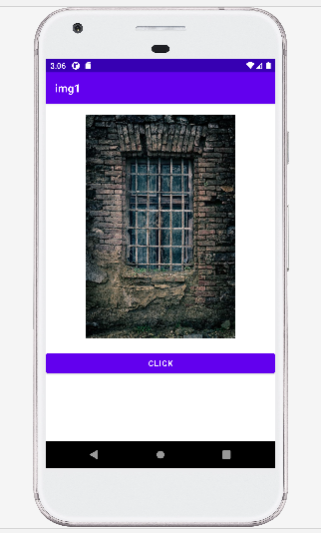

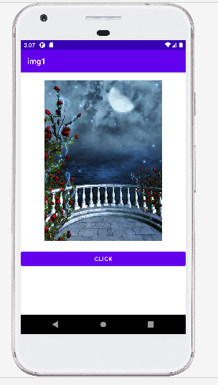

**ListView**

**activity_main.xml**

*<?*xml version="1.0" encoding="utf-8"*?>*<LinearLayout xmlns:android="http://schemas.android.com/apk/res/android" xmlns:app="http://schemas.android.com/apk/res-auto" xmlns:tools="http://schemas.android.com/tools" android:layout_width="match_parent" android:layout_height="match_parent" tools:context=".MainActivity" android:orientation="vertical"> <ListView android:layout_width="match_parent" android:layout_height="wrap_content" android:id="@+id/list"/></LinearLayout> </LinearLayout>

**Mainactivity.java**

package com.example.listview_403;import androidx.appcompat.app.AppCompatActivity;import android.os.Bundle;import android.view.View;import android.widget.AdapterView;import android.widget.ArrayAdapter;import android.widget.ListView;import android.widget.Toast;public class MainActivity extends AppCompatActivity { ListView myList ; String countryList[] ; @Override protected void onCreate(Bundle savedInstanceState) { super.onCreate(savedInstanceState); setContentView(R.layout.*activity_main*); myList = findViewById(R.id.*list*) ; countryList = getResources().getStringArray(R.array.*country*) ; ArrayAdapter<String> arrayAdapter = new ArrayAdapter<String>(this, R.layout.*textview_layout*, countryList); myList.setAdapter(arrayAdapter); myList.setOnItemClickListener(new AdapterView.OnItemClickListener() { @Override public void onItemClick(AdapterView<?> adapterView, View view, int i, long l) { Toast.*makeText*(MainActivity.this, "You have\n" + " \n" + "clicked:", Toast.*LENGTH_SHORT*).show(); } }); }}

**strings.xml**

<resources> <string name="app_name">listview_403</string> <string-array name="country"> <item>India</item> <item>China</item> <item>Pakistan</item> <item>USA</item> <item>UK</item> </string-array></resources>

**Output**

